Checkpoint 2 Evidence
Estructura de Datos y Algoritmos Computacionales
Esteban Ademir Cañas Rojas, Carlos Mario Alas Parada, Louis Alejandro Soto
2026
In this docx you will see the evidence of our code working and the organization and the strict modularity of the code

Evidencia de ejecución

Generación de Mazmorra:
In this part we will see how our Dungeon auto-generates itself
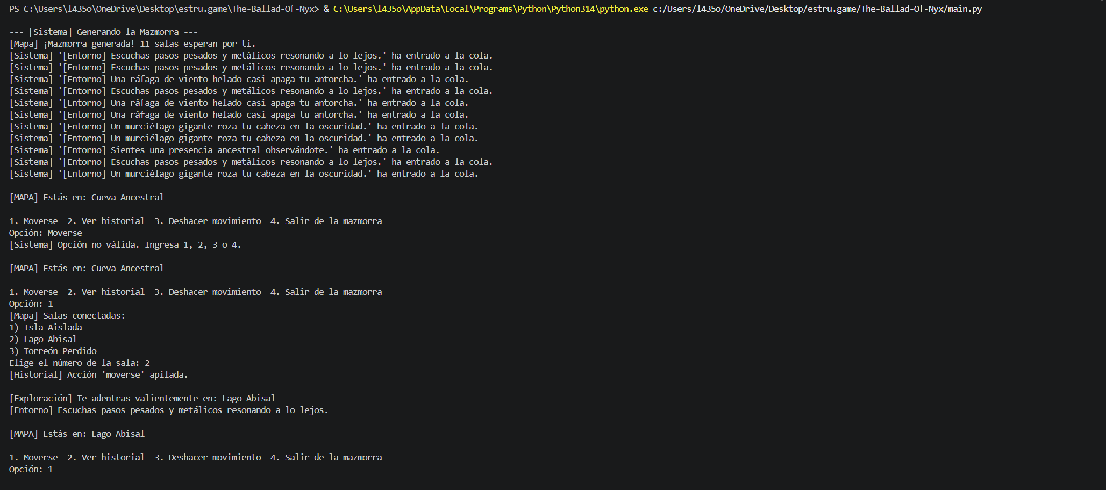
In the Screenshot we can see how the game creates 11 different rooms of our “dungeon” and we can also see how we can use the numbers on our keyboard to move through the rooms but I will make more of an emphasis down the line in the next part

Movimientos del Jugador:
In this part we will see how the player moves around the Dungeon to find materials to use in the crafting system
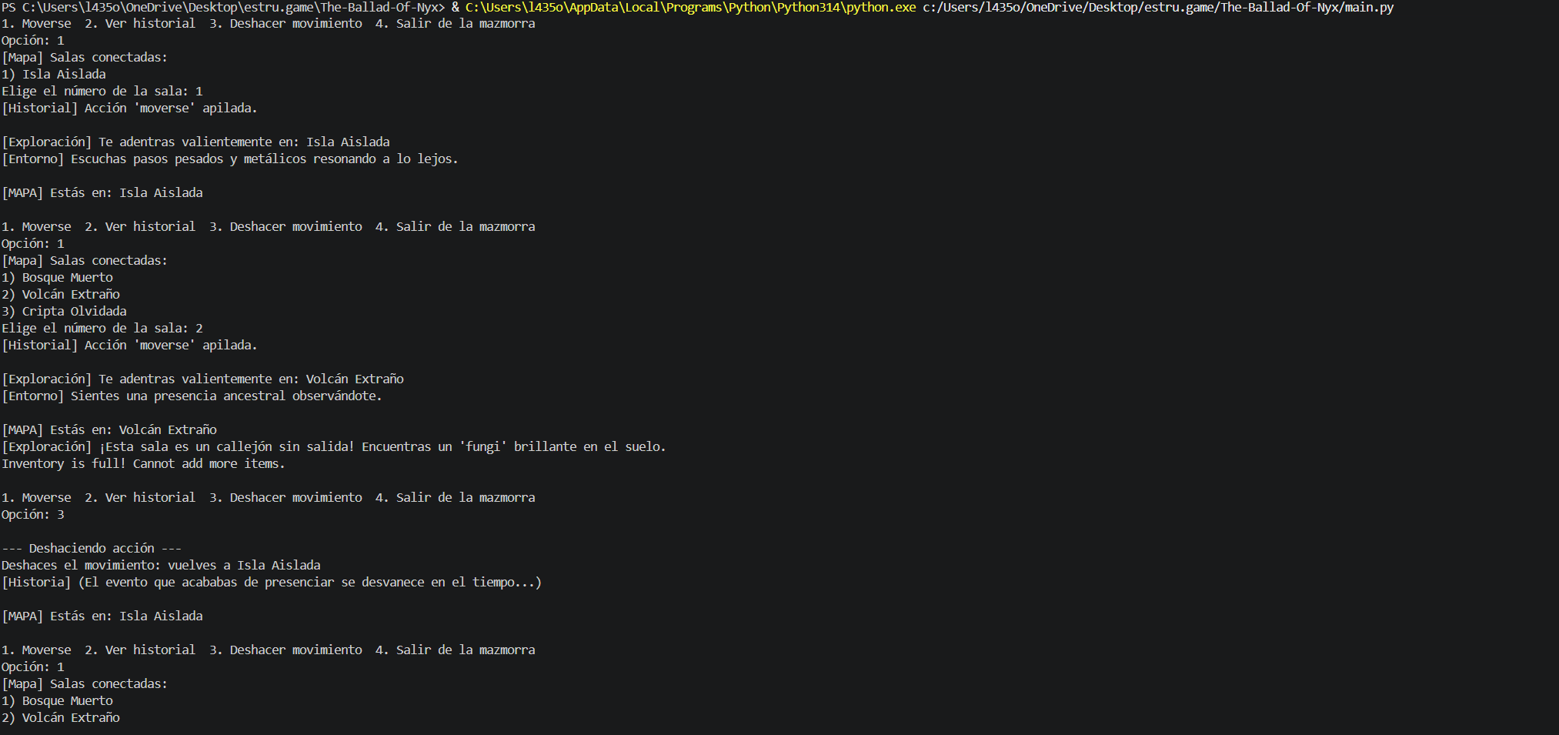
As you can see when we use the command to enter the dungeon and the dungeon auto generates the game asks us what we want to do next and if we use the “movese” command we can see the game telling us what rooms are connected and where we can move

The Crafting system
Now in the last part we saw how in the dungeon we can find objects and items but what do we use them for? Well we use them to craft potions for battle and that’s when the crafting system comes into play
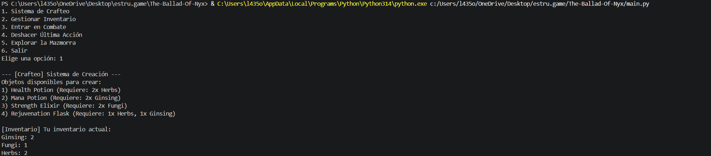
Now as we can see when we pull up the crafting system we see all the thing that we can craft and what we need to craft them as well as our current inventory
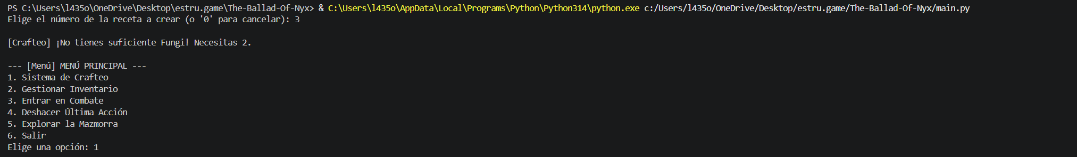
If we see here if we try to craft something but don’t have the materials for it the crafting doesn’t happen and we are ejected from to the main menu
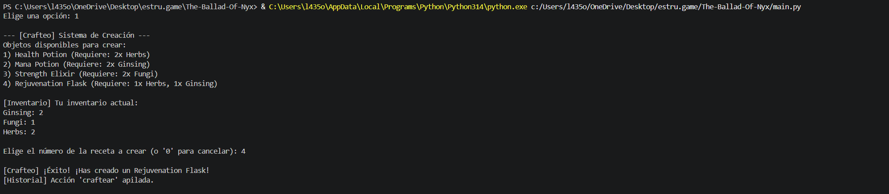
Now if we go back and pick something we do have the items for the game will craft it and will add it to our inventory
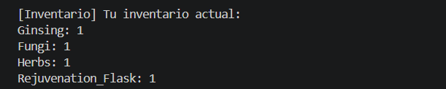

Procesamiento de Eventos
Now in other screenshots we have seen the implementation of a queue but in this part will see it used more thoroughly in the combat part of the game when it comes to the turn system
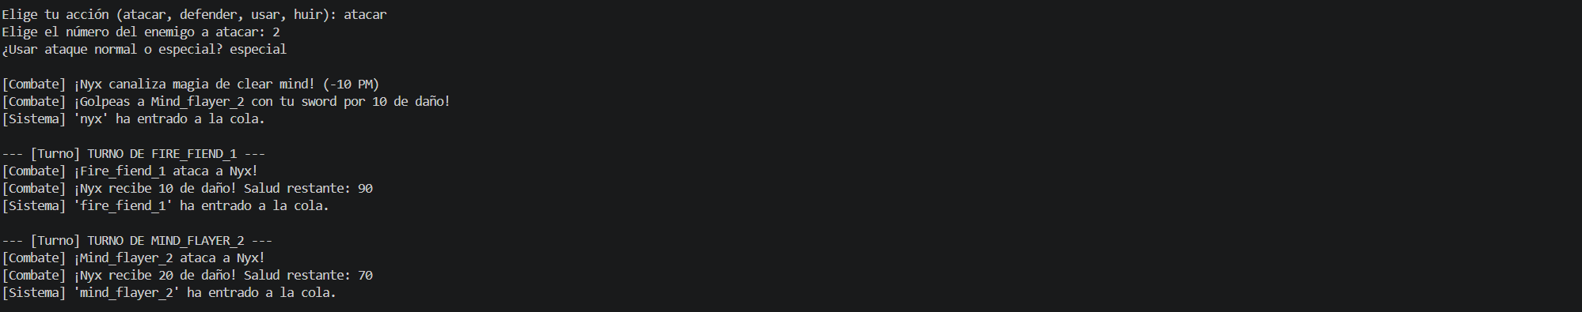
In this part we see how our turn system uses a queue to see who attacks and who goes next in the battle like normal turn base rpg

Sistema de Combate
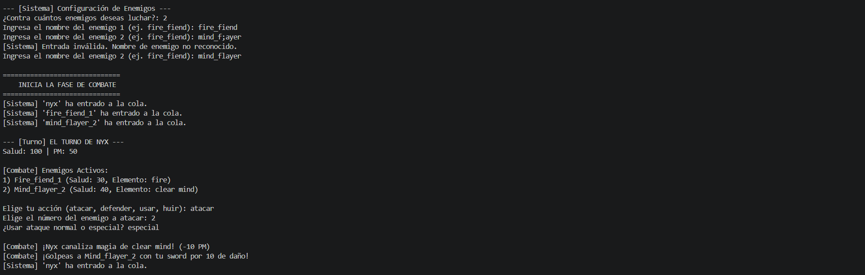
Now in the screenshot we can see the enemy config and the combat system in the enemy config we choose the number of enemies we would like to fight and what enemies we will put into battle and in the combat system we see the queue system and how we attack

Acción de Deshacer
The backtracking system can be used for undoing something like uncrafting a potion
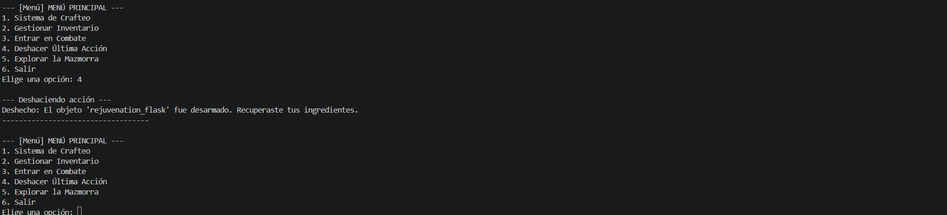
As you can see if we made a potion that we didn’t mean to make we can use the backtracking option to undo it and recover our ingredients
And we use the backtracking system in the dungeon part and return to the last room we were just in before

Historial de Acciones
Now as for the action history it serves more as a background process rather then showing up in the game its used for the backtracking system to function

Manejo de Casos Límite
Now for this part we will demonstrate some cases that could lead to the code breaking but one case has already been shown if you remember I showed what happened if we try to craft something without materials the game seeing we don’t have the items required and automatedly says we don’t have the materials
But now I will show what happens if we try to use a wrong command
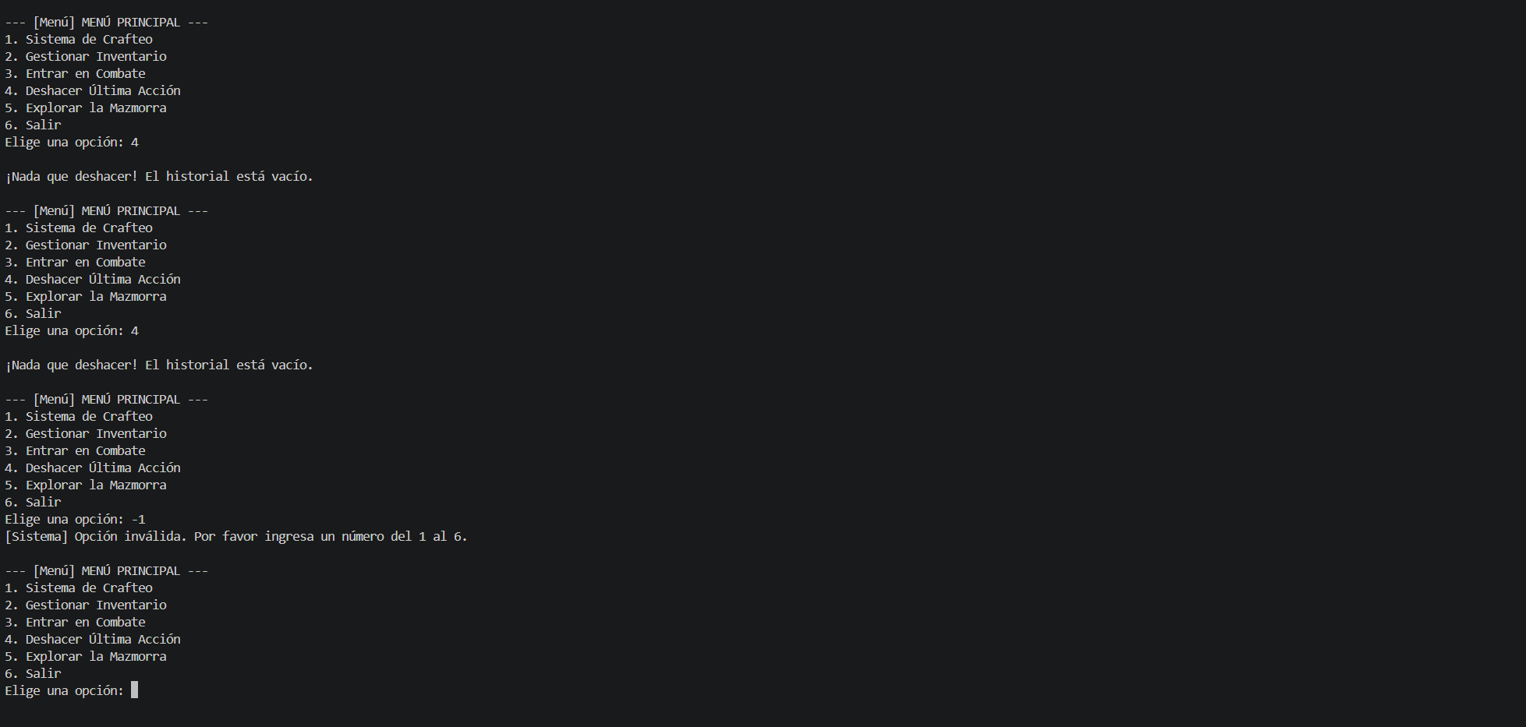
Now if you can see here are two more ways the code could have broken in the first we see how the history is empty and yet we try to go back but the game just says that there are no points to go back to
As for the other point we try to enter something that’s not in the menu so the games tells us to please select a valid option and returns to the options

Organización y estándares del Código

Modularidad Estricta
Now while making the project we were asked to make different .py files for each function and import them into the main game so in the next Screenshots we will show that
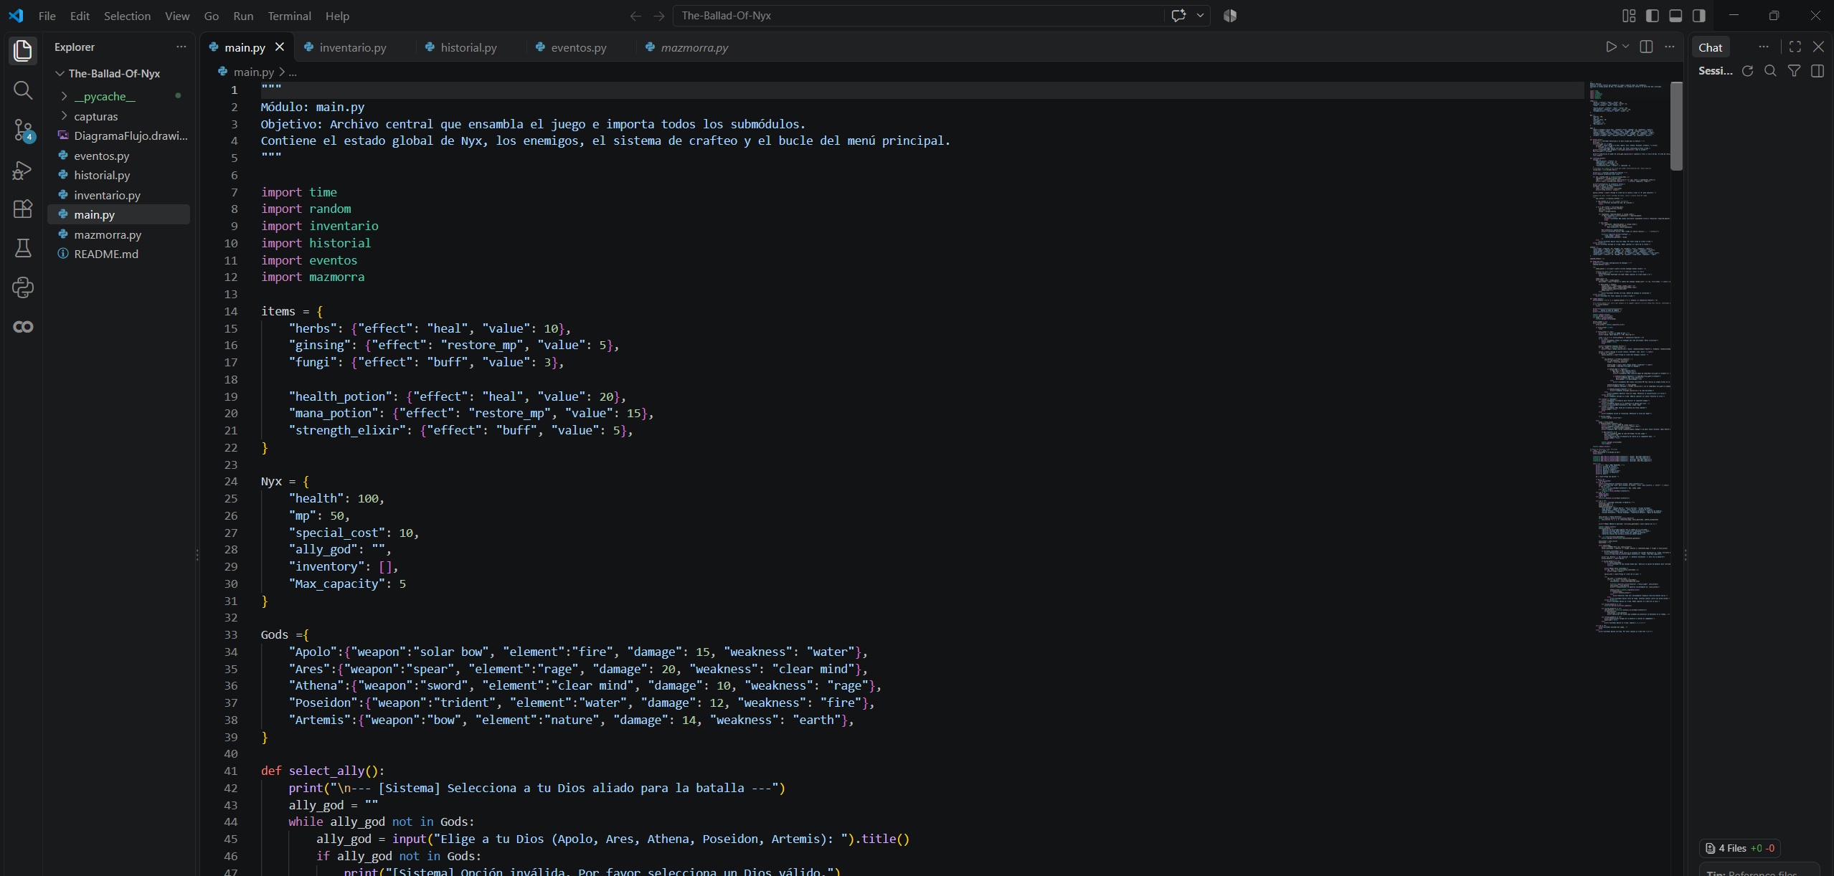
on the left of the screenshot is the file explorer where all the file a folder is located and as you can see we have eventos.py, historial.py, inventario.py, mazmorra.py, and the main.py
and in the main.py we can see that all the other files have been imported into the main making the main.py modular

Docstrings Obligatorios
